11th grade exam for 1st unit; “Welcome to learning” A version
- Complete the chart /3 points/
 | Country | Nationality | Language
1 | Germany
2 |  | French
3 |  |  | Italian
- Match the words to their definitions /4 points/
- To devote a. a book in digital form
- A language gadget b. the way in which a word is articulated
- E-book c. a tool used for learning
- Pronunciation d. to spend
- Use punctuation marks in these sentences. /6 points/
- Look Somebody is dancing
- However it was late I could attend the meeting
- I like an apple kiwi and an orange
- Complete the sentences with gerund form . /4 points/
- My brother blamed me ….. (break) his favorite vase.
- I’m proud of …….. (work) as an electrician.
- (Use) ……….. computer is easier than you think.
- (Learn) ………... English is fun.
- Decide the verbs gradual change (GC) or present action (PA) /4 points/
- I feel that things are getting better.
- I’m feeling the red silk.
- They are giving presents to homeless children
- More and more people are giving up smoking.
- Combine the sentences using the words in brackets. /4 points/
- The teacher tested the students. She wanted to see if they remembered the things they had learnt. (in order to)
- He tried to hide the broken vase. He didn’t want to be punished. (so that)
- Mark is going to repair the roof. Then the rain won’t come in. (so that)
- We often switch off the heating. It saves money. (in order to)

Total 25 points Good luck

11th grade exam for 1st unit; “Welcome to learning” B version
- Complete the chart /3 points/
 | Country | Nationality | Language
 | Poland
 |  | English
 |  |  | Japanese

- Match the words to their definitions /4 points/
- Period a. a sign used to ask question
- Colon b. a sign at the end of the sentence
- Question mark c. a sign to separate items in a list
- Comma d. a sign used before a list
- Use punctuation marks in these sentences. /6 points/
- Listen Somebody is singing
- Although it was late I could attend the meeting
- I like dress skirt and shirt
- Complete the sentences with gerund forms . /4 points/
- Mary was proud of ….. (enter) the university after hard work.
- My brother can’t blame me for ….. (break) his favorite vase.
- (Memorize)………… new words is helpful to learn English.
- (Drink)……………… too much Cola is bad for our health.
- Decide the verbs gradual change (GC) or present action (PA) /4 points/
- Her broken arm is getting better now.
- They are playing tennis with their friends
- A lot people are learning English.
- I’m losing weight these days.
- Combine the sentences using the conjunction in brackets /4 points/
- I turned up the radio. I wanted to listen to the news. (so that)
- Sue lowered the volume on the TV set. She didn’t want to disturb her roommate. (so that)
- He tried to find a car park. He wanted to park his car. (in order to)
- Andrew’s friends visited him. They wanted to congratulate him on his graduation. (in order to)

Total 25 points Good luck

KEY to unit-1 A version
- Complete the chart /3 points/
 | Country | Nationality | Language
1 | Germany | German | German
2 | France | French | French
3 | Italy | Italy | Italian
- Match the words to their definitions /4 points/
1d, 2c, 3a, 4b
- Use punctuation marks in these sentences. /6 points/
- Look! Somebody is dancing.
- However, it was late I could attend the meeting.
- I like an apple, kiwi and an orange.
- Complete the sentences with gerund form . /4 points/
- breaking 2. working 3. Using 4. Learning
- Decide the verbs gradual change (GC) or present action (PA) /4 points/
1. GC, 2. PA, 3. PA, 4. GC
- Combine the sentences using the words in brackets. /4 points/
- The teacher tested the students in order to see if they remembered the things they had learnt.
- He tried to hide the broken vase so that he didn’t want to be punished.
- Mark is going to repair the roof so that the rain won’t come in.
- We often switch off the heating in order to save money.
B version
- Complete the chart /3 points/
 | Country | Nationality | Language
 | Poland | Polish | Polish
 | England | English | English
 | Japan | Japanese | Japanese
- Match the words to their definitions /4 points/
1b, 2d, 3a, 4c
- Use punctuation marks in these sentences. /6 points/
- Listen! Somebody is singing.
- Although it was late, I could attend the meeting.
- I like dress, skirt and shirt.
- Complete the sentences with gerund forms . /4 points/
1. entering 2. breaking 3. Memorizing 4. Drinking
- Decide the verbs gradual change (GC) or present action (PA) /4 points/
1. GC 2. PA 3. PA 4. GC
- Underline the correct conjunction /4 points/
- I turned up the radio so that I wanted to listen to the news.
- Sue lowered the volume on the TV set so that she didn’t want to disturb her roommate.
- He tried to find a car park in order to park his car.
- Andrew’s friends visited him in order to congratulate him on his raduation
11th grade exam for 2nd unit; “People and their jobs”
A version

- Unjumble the words to make correct jobs /4 points/
- JATORNI
- LIPOTIANCI
- ETPO
- ERHOEKEUSEP
- Create nouns by add an appropriate endings /4 points/
- Beauty-
- Veterinary-
- Interpreting-
- Psychology -
- Use the GERUND or INFINITIVE forms of the verbs in brackets /5 points/.
      - Henry is quite good at (make up) stories.
      - They seem (have) plenty of money.
      - The children are excited about ………………..(go) to the movies.
      - Do you have any difficulty in…………(speak) English?
      - Jim can’t stand (be) interrupted.
- Complete the sentences using Future perfect tense. /5 points/
- ….. you….. (graduate) your school by 2020?
- I …. (not start) my career by the end of the year.
- I ….. (do) this cake by this evening.
- We …..... (know) each other for 20 years by next September
- He ………(not finish) his project by tomorrow.
- Underline correct answer /5 points/
      - will/shall you help me to open this door?
      - will/shall I carry this suitcase for you?
      - The thief was accused of to steal/stealing a woman purse.
      - When I was a kid, I hated to go/going to bed early.
      - I wish it is/was raining now.
- Translate the sentences. /2 points/
- I wish I hadn’t broken his favorite vase.
- Надад найз залуу минь өнөөдөр цэцэг өгөөсэй

Total point=25 Good luck!

11th grade exam for 2nd unit; “People and their jobs”
B version

- Unjumble the words to make correct jobs /4 points/
- POERRT
- EDGJU
- CONORDUCT
- PISTERHAT
- Create nouns by add an appropriate endings. /4 points/
- Poem-
- Surgery-
- Politics -
- Pharmacy –
- Use the GERUND or INFINITIVE forms of the verbs in brackets /5 points/.
      - Henry isn’t quite good at (make up) stories.
      - Bolor seems (have) a lot of money.
      - The children are excited about ………………..(go) to the movies.
      - Would you like (listen) to some music?
      - I can’t stand (be) pointed.
- Complete the sentences using Future perfect tense. /5 points/
- ….. he….. (enter) your school by 2024?
- I …. (not finish) my work by the end of the year.
- She ….. (make) this cake by this evening.
- He …….(write) his essay by the time his mother arrives.
- They …..(not arrive) by tomorrow evening.
- Underline correct answer /5 points/
      - will/shall you pass the salt to me?
      - When I was a kid, we enjoyed to go/going to the amusement park.
      - I wish it rain/rained tomorrow.
      - will/shall I help you to carry this suitcase?
      - Jack advised me………….to rent/renting a new apartment.
- Translate the sentences. /2 points/
- I wish I had met him yesterday.
- Надад найз охин минь өнөөдөр бялуу өгөөсэй

Total point=25 Good luck

KEY to unit-2 A version
- Unjumble the words to make correct jobs /4 points/
- JANITOR 2. POLITICIAN 3. POET 4. HOUSEKEEPER
- Create nouns by add an appropriate endings /4 points/
- Beautician, 2. Veterinarian 3. Interpreter 4. Psychologist
- Use the GERUND or INFINITIVE forms of the verbs in brackets /5 points/.
      - making up 2. to have 3. going 4. speaking 5. being
- Complete the sentences using Future perfect tense. /5 points/
1. Will you have graduated 2. won’t have started 3. will have done 4. will have known 5. won’t have finished
- Underline correct answer /5 points/
      - will 2. shall 3. stealing 4. going 5. was
- Translate the sentences. /2 points/
- Би түүний дуртай ваарыг хагалаагүй ч болоосой
- I wish my boyfriend gave me a flower today.

B version

- Unjumble the words to make correct jobs /4 points/
- PORTER 2. JUDGE 3. CONDUCTOR 4. THERAPIST
- Create nouns by add an appropriate endings. /4 points/
1. Poet 2. Surgeon 3. Politician 4. Pharmacist –
- Use the GERUND or INFINITIVE forms of the verbs in brackets /5 points/.
1. making up 2. to have3. going 4. to listen 5. being
- Complete the sentences using Future perfect tense. /5 points/
1. Will he have entered 2. won’t have finished 3. will have made 4. will have written 5. won’t have arrived
- Underline correct answer /5 points/
1. will 2. going 3. rained 4. shall 5. to rent
- Translate the sentences. /2 points/
- Би өчигдөр түүнтэй уулзсан ч болоосой.
- I wish my girlfriend gave me a cake today.

11th grade exam for 3rd unit; “Life stories”
A version
- Match the phrases to the opposites /4 points/
- if my memory serves me right a. with no interest
- out of curiosity b. safe and secure
- devastated c. covered
- exposed to d. not remembering correctly
- Write synonyms for the given words /4 points/
- donate
- motivate
- ignore
- blockbuster
- Finish the sentences using the words and phrases /3 points/
a while ago an addiction tricky great anxiety satisfied internal struggles
… .
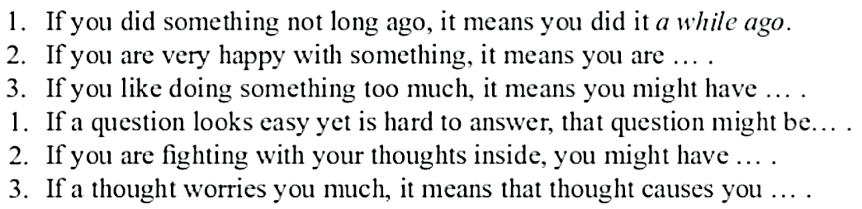
- Fill in the correct words; lately, so far and all my life /4 points/
- I have sung opera …………………….
- We haven’t played football ………………..
- I have written 3 letters …………….
- …………….. we have baked three loaves of bread
- Write the verbs in brackets in past simple or past perfect /5 points/
- When we _______________ (arrive) at the station, the train had already left.
- We got home to find that someone _________________ (break) into the house.
- I opened the fridge to find someone ___________________ (eat) all my chocolate.
- I had known my husband for three years when we ____________ (get) married.
- Julie was very pleased to see that John _____________________ (clean) the kitchen.
- Write regrets using “I wish” clause /5 points/
- I couldn’t travel to New York. I didn’t have enough money.
I wish I ………… /have/ enough money to travel to New York.
- They didn’t score a goal.
I wish they ………………./score/ a goal.
- They lost the photo.
I wish they ………………./not lose/ the photo.
- I didn’t study hard at school.
I wish I …………………………/study/ harder at school.
- They had an accident because of the bad weather.
I wish the weather /not be/ so bad.
Total point=25 Good luck!
11th grade exam for 3rd unit; “Life stories”
B version
- Match the phrases to the opposites /4 points/
- without any doubt a. wealthy
- ignore b. typical
- underprivileged c. hesitatingly
- exceptional d. pay attention to
- Write synonyms for the given words /4 points/
- pioneer
- devastated
- exposed to
- successful film
- Finish the sentences using the words and phrases /3 points/
a while ago an addiction tricky great anxiety satisfied internal struggles
- Fill in the correct words; lately, so far and all my life /4 points/
- Have you seen my wallet………………..?
- ……………………I have felt really tired.
- Have you exercised ………………………?
- She has lived in Liverpool ……her……….
- Write the verbs in brackets in past simple or past perfect /5 points/
- We had already eaten when John ______________________ (come) home.
- Last year Juan ________________________________ (pass) all his exams.
- When I ___________ (get) to the airport I discovered I had forgotten my passport.
- I went to the library, then I _______________ (buy) some milk and went home.
- I opened my handbag to find that I _______________ (forget) my credit card.
- Write regrets using “I wish” clause /5 points/
- I’m 80 years old. I’m lonely. I only have one child
I wish I …………………. /have/ more children.
- I didn’t have a car. So I couldn’t go camping with my friends.
I wish I …………………./have/ a fast car.
- They were not quiet last evening.
I wish they…………../be/ quieter last evening.
- The train was late.
I wish the train ……………………/not be/ late.
- My sister invited me to her party, but I didn’t go.
I wish I ………………………./go/to my sister’s party.
Total point=25 Good luck!
KEY to unit-3
A version
I. Match the phrases to the opposites /4 points/
1d, 2a, 3b, 4c
  - Write synonyms for the given words /4 points/
- give 2. inspire 3. pay no attention to 4. successful film
  - Finish the sentences using the words and phrases /3 points/
1.a while ago 2. satisfied 3. an addiction
  - Fill in the correct words; lately, so far and all my life /4 points/
1. all my life, 2. lately 3. so far 4. So far
  - Write the verbs in brackets in past simple or past perfect /5 points/
1. arrive 2. had broken 3. had eaten 4. got 5. had cleaned
  - Write regrets using “I wish” clause /5 points/
1. I wish I had had enough money to travel to New York.
2. I wish they had scored a goal.
3. I wish they hadn’t lost the photo.
4. I wish I had studied harder at school.
5. I wish the weather hadn’t been so bad.

B version

  - Match the phrases to the opposites /4 points/
1c, 2d, 3a, 4b
  - Write synonyms for the given words /4 points/
- role model, 2. very sad 3. open to 4. blockbuster
  - Finish the sentences using the words and phrases /3 points/
1. tricky 2. internal struggles 3. great anxiety
  - Fill in the correct words; lately, so far and all my life /4 points/
- lately 2. So far, 3. lately 4. all her life
  - Write the verbs in brackets in past simple or past perfect /5 points/
1. came 2. passed 3. got 4. bought 5. had forgotten
  - Write regrets using “I wish” clause /5 points/
- I wish I had had more children.
- I wish I had had a car.
- I wish they had been quieter last evening.
- I wish the train hadn’t been late.
- I wish I had gone to my sister’s party.

11th grade exam for 4th unit; “Buildings and design” A version
- Put the words in the correct column /9 points/
concrete, a roof, a shade, a garage, glass, bricks, a playground, a basement, a column
- Parts of the building:….…………….......................................……….......
- Construction materials: ……………………………………………..............
- Objects outside of the building: …………………………...…………..........
- Read and choose the correct words and complete it /5 points/
A SHADE A PLAYGROUND PEDESTRIAN STREET A BASEMENT AN ANTENNA
- An area used for outdoor play; …………………………………
- A conductor electromagnetic waves are sent out and received; ………………
- A ground level of the building; …………………………………
- A road for people who walk; …………………………………
- An object that protects from the Sun; ………………………………
- Rewrite the sentences using the passive forms. /6 points/
- He found the child in the park.
- They deliver the newspaper in the morning.
- She will choose the design team on 2nd of April.
- They visited that museum yesterday.
- She has designed the eco-friendly playgrounds.
- We will build the basement hall next month.
- Put the verbs in bracket in the correct passive form. /6 points/
1. The hospital ……………..…………………….. (build) 2 years ago.
2. The broken part of the bridge …………………………………..(repair) next month.
3. This building …………………… (complete) in 1998.
4. The Golden Gate Bridge ……………………… (locate) in USA.
5. This glass bridge ………………………… (visit) every year by thousands of tourists.
6. The basement wall ………………………… (paint) tomorrow.
- Read the text and answer the question. /4 points/
The Golden Gate Bridge connects the city of San Francisco and San Francisco Peninsula. It spans the Golden Gate a strait between the Pacific Ocean an San Francisco Bay-that’s where the name Golden Gate Bridge comes from. Construction of bridge started in 1933 and was completed in 1937. The project was designed by Architects Joseph Strauss Irving Morrow and Charles Alton Ellis. The bridge rises 230 meters above the water. With its total length of 1970 meters it was the longest suspension bridge in the world until 1964. The bridge is part of the United States Highway 101, has six lanes and a footpath on each side.
- What is the name of the bridge?
- Where is it located?
- When was its construction began?
- When was it completed?

TOTAL- 30 POINTS GOOD LUCK☺☺☺

11th grade exam for 4th unit; “Buildings and design” B version
- Put the words in the correct column /9 points/
A window pane, wood, an antenna, a road, an elevator, granite, a shade, a wall, stone
- Parts of the building: ………………………………………………
- Construction materials: ……………………………………………
- Objects outside of the building: ……………………………………
- Read and choose the correct words and complete it /5 points/
AN ENTRANCE A WINDOW PANE AN ELEVATOR A SHADE CONCRETE
- Building material made from stone, sand, cement and water; ………………
- A gate that people enter; ……………
- A plate of glass in window is called; …………………………………
- An object that protects from the Sun; …………………………………
- A machine that carries people up and down;………………………………
- Rewrite the sentences using the passive forms. /6 points/
- Architects constructed this long bridge in 1952
- People use this room as a conference hall.
- The company will build a new bridge
- Ben repaired my computer yesterday.
- He has bought a new car. .
- We will repair the broken parts of the bridge
- Put the verbs in bracket in the correct passive form. /6 points/
- These houses ……………..…………………….. (build) next year.
- The garage …………………………………..(construct) last month.
- The Golden Gate bridge ………………..………… (complete) in 1937.
- The Burj Kalifa ……………………… (locate) in Dubai, United Arab Emirates.
- This long road ……………………………...…… (repair) every year.
- A new children palace ………………………… (build) very soon.
- Read the text and answer the question. /4 points/
Burj Khalifa in Dubai, United Arab Emirates, is the tallest building in the world. Its construction was started in September 2004 and was completed in October 2009. The building was opened in 2010 as a part of Downtown Dubai which also includes Dubai Mall and famous Dubai dancing Fountains. As the tallest structure it stands a total height of 829 meters. The primary structure is reinforced concrete. It contains a total of 57 elevators and 8 escalators. The building has received many awards. The tower contains the world’s highest mosque on the 158th floor, The world’s highest swimming pool on the 75th floor. The pyramid-shaped skyscraper houses 900 residences and office suites.
- Where is it located?
- When was it completed?
- How many elevators and escalators does it contain?
- How many residences and office suites are there in the pyramid-shaped skyscraper?
TOTAL- 30 POINTS GOOD LUCK☺☺☺

KEY to unit-4 A version
I. Put the words in the correct column /9 points/
- Parts of the building: a roof, a column a basement,
- Construction materials: concrete, glass, bricks,
- Objects outside of the building: a shade, a playground, a garage,
II. Read and choose the correct words and complete it /5 points/
1. a playground 2. an antenna 3. a basement 4. pedestrian street 5. a shade
III. Rewrite the sentences using the passive forms. /6 points/
- The child was found in the park /by him/.
- The newspaper is delivered in the morning /by them/.
- The design team will be chosen on 2nd of April /by her/.
- That museum was visited /by them/ yesterday.
- The eco-friendly playgrounds has been designed by her.
- The basement hall will be built next month.
IV. Put the verbs in bracket in the correct passive form. /6 points/
1. was built 2. will be repaired 3. was completed 4. is located 5. is visited 6. will be painted
- Read the text and answer the question. /4 points/
- The name of the bridge is The Golden Gate Bridge?
- It is located in San Francisco
- Its construction began in 1933.
- It was completed in 1937.
B version
I. Put the words in the correct column /9 points/
- Parts of the building: A window pane, an elevator, a wall,
- Construction materials: wood, granite, stone
- Objects outside of the building: an antenna, a road, a shade,
II. Read and choose the correct words and complete it /5 points/
1. concrete 2. an entrance 3. a window pane 4. a shade 5. an elevator
III. Rewrite the sentences using the passive forms. /6 points/
- This long bridge was constructed in 1952 /by architects/
- This room is use as a conference hall.
- A new bridge will be built by the company
- My computer was repaired by Ben yesterday.
- A new car has been bought by him .
- The broken parts of the bridge will be repaired by us.
IV. Put the verbs in bracket in the correct passive form. /6 points/
1. will be built 2. was constructed 3. was completed 4. is located 5. is repaired 6. will be built
V. Read the text and answer the question. /4 points/
      - It is located in Dubai, United Arab Emirates?
      - It was completed in October 2009.
      - It contains a total of 57 elevators and 8 escalators.
      - There are 900 residences and office suites in the pyramid-shaped skyscraper.
11th grade exam for 5th unit; “Natural disaster”
A version
- Match the natural disasters to their definitions. /4 points/
- A tsunami a. a violent wind that has a circular movement
- A hurricane b. a mass of rock and earth moving suddenly and quickly down a steep slope
- A flood c. a large wave caused by a violent movement of the earth under the sea
- A landslide d. an overflow of rain water
- Complete the sentences using the given words in italics /4 points/
black dzud, iron dzud, avalanche, earthquake
- We will take several hours to dig people out of the snow from the ………
- Several layers of ice are often formed over the snow and it is called
- This village will completely destroyed by a great ……… last year
- No snow falls and extreme low temperature in years causes ….. ……………
- Read the sentences and underline an appropriate modal verb /5 points/
- The mountains are popular because people can / must ski and climb there.
- You have to / mustn’t do mountain sports alone.
- We mustn’t / don’t have to worry about avalanches if there’s no snow.
- We are allowed to/ supposed to smoke in this restaurant.
- Her dogs aren’t allowed to/ supposed to sleep on the bed.
- Use the present perfect tense to fill in the blanks /5 points/
- What ……………………………………… (she / learn) since last Christmas?
- How many friends………………………. (you / make)?
- I ………………………………….. (just / have) lunch.
- How many games………………………(the team / win) so far this season?
- Your car looks very clean. (you / wash) it?
- Rewrite the sentences in passive form /5 points/
- Someone has already paid the electrician for his work.
- The author has written a special edition for children.
- The burglars has cut a huge hole in the steel door.
- The boys have damaged the television
- They have taken his aunt to hospital
- Translate the sentences below /2 points/
- There are 7 million people in the world suffering from famine
- The cattle can’t reach the grass because of heavy snow.

Total 25 points Good luck
11th grade exam for 5th unit; “Natural disaster”
B version
- Match the natural disasters to their definitions. /4 points/
- A drought a. a sudden violent movement of the earth’s surface
- An avalanche b. a long period when there is little or no rain
- An earthquake c. a severe snow storm with strong winds
- A blizzard d. dangerous slide of snow down a mountain
- Complete the sentences using the given words in italics /4 points/
white dzud, stormy dzud, flood, wildfire
- There was a lot of rain and ………….. covered whole street.
- The sheep and goats went downwind during the ………………
- The …………… spread through whole village burnt most of the forest.
- A heavy snowfall causes ………………….
- Read the sentences and underline an appropriate modal verb /5 points/
- People must / shouldn’t go on the snow when there’s a danger of avalanches.
- If you are stuck in an avalanche, you don’t have to /mustn’t climb out.
- You have to / don’t have to wait for help.
- You aren’t allowed to/ supposed to smoke in your mother's room. She hates smoking
- My son is allowed to/ supposed to wash his face before going to bed.
- Use the present perfect tense to fill in the blanks /5 points/
- How many letters…………………….(you / write) since the beginning of the month?
- In her whole lifetime, Mary (never / see) snow.
- I don’t know where Ammy is (you / see) her?
- Mr. Clark …………………………………………..(work) in a bank for 15 years.
- The telephone……………………………(ring) four times in the last hour
- Rewrite the sentences in passive form /5 points/
- A famous designer has redecorated the hotel.
- The gardener has planted some trees.
- Someone has broken the crystal vase.
- His parents have given him a new house
- He has invited 30 people to his party
- Translate the sentences below /2 points/
- Have you ever faced an earthquake?
- Citizens are supposed to follow the safety rules during an avalanche
Total 25 points Good luck

KEY to unit-5
A version
- Match the natural disasters to their definitions. /4 points/
1c, 2a, 3d, 4b
- Complete the sentences using the given words in italics /4 points/
1. avalanche, 2. iron dzud, 3. earthquake 4. black dzud,
- Read the sentences and underline an appropriate modal verb /5 points/
- can 2. mustn’t 3. don’t have to 4. are allowed to 5. aren’t allowed to
- Use the present perfect tense to fill in the blanks /5 points/
- has she learned 2. have you made 3. have just had 4. has the team won 5. have you washed
- Rewrite the sentences in passive form /5 points/
- The electrician for his work has already been paid by someone
- A special edition for children has been written by the author.
- A huge hole in the steel door has been cut by the burglars.
- The television has been damaged by the boys.
- His aunt has been taken to hospital /by them/
- Translate the sentences below /2 points/
- Дэлхий дээр 7 сая хүн өлсгөлөнгөөр шаналж байна.
- Их цаснаас болж үхэр бэлчээртээ хүрч чадахгүй байна.

B version
I. Match the natural disasters to their definitions. /4 points/
1b, 2d, 3a, 4c
II. Complete the sentences using the given words in italics /4 points/
1. flood, 2. stormy dzud, 3. wildfire 4. white dzud,
III. Read the sentences and underline an appropriate modal verb /5 points/
1. shouldn’t 2. mustn’t 3. have to 4. allowed to 5. supposed to
IV. Use the present perfect tense to fill in the blanks /5 points/
1. have you written 2. has never seen 3. Have you seen 4. has worked 5. has rung
V. Rewrite the sentences in passive form /5 points/
- The hotel has been redecorated by a famous designer
- Some trees have been planted by the gardener.
- The crystal vase has been broken by someone.
- A new house has been given him by his parents
- 30 people have been invited to his party /by him/
VI. Translate the sentences below /2 points/
            - Чи\Та газар хөдлөлттэй учирч байсан уу?
            - Иргэд цасан нурангийн үеэр аюулгүйн дүрмүүдээ баримтлах хэрэгтэй.

11th grade exam for 6th unit; “Habitat interaction” A version

- Match the words with their definitions /5 points/
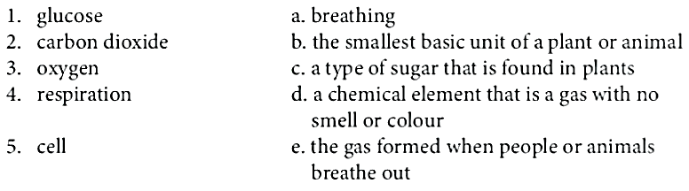
- Add four words for each line /4 points/
- Habitat interaction words; adaptation, ……….,……..,………..,………..
- Animals in food web; scavenger, ……….,……..,………..,………..
- Use these words to make sentences in the passive voice./5 points/.
- produce | too much waste | in developed countries
..................................................................................
- cars | big cities | block
..................................................................................
- cover | plastic bags and bottles | beaches
.................................................................................
- on roads | find | millions of dead animals | every year
..................................................................................
- pollute | air | factories and vehicle exhausts
.................................................................................
- Make an object question and a subject question. /4 points/
- The car is in the garage.
- Object question: ____________________________________________
- Subject question: ___________________________________________
- Julie loves ice-cream.
- Object question: ___________________________________________
- Subject question: ___________________________________________
- Fill in the blanks with appropriate prepositions /3 points/
      - Who are you waiting ________?
      - A: Have you heard John's getting married again?! B: Really? Who ______?
      - A: I had a terrible nightmare last night. B: Oh no, what _______?
- Underline the correct answer /4 points/
1. Both/Neither/Either houses are very expensive.
2. Both/Neither/Either of us wanted to go to the cinema. We don’t like it.
3. Would both/neither/either of you fancy eating out today?
4. She's both/neither/either shy and quiet.

Total point=25 Good luck!

11th grade exam for 6th unit; “Habitat interaction” B version
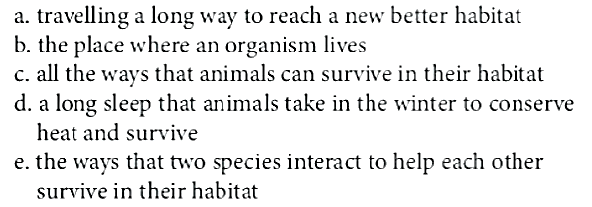
I. Match the words with their definitions /5 points/
            - habitat
            - adaptation
            - migration
            - a symbiosis

            - hibernation

  - Add four words for each line /4 points/
      - Terms in food chain; carnivore, ……….,……..,………..,………..
      - Words in photo synthesis; oxygen, ……….,……..,………..,………..
  - Use these words to make sentences in the passive voice./5 points/.
- cut down | in South America and Asia | rain forests
..............................................................................................
- fill | water | toxic pollutants | with
.............................................................................................
- see | can | on the climate | the human influence
...............................................................................................
- overpopulate | our planet
................................................................................................
- do | about it | nothing
…………..................................................................................
  - Make an object question and a subject question. /4 points/
      - The food was on the table.
- Object question: ___________________________________________
- Subject question: ___________________________________________
      - The student is from Colombia.
- Object question: __________________________________________________
- Subject question: _________________________________________________
  - Fill in the blanks with appropriate prepositions /3 points/
- She's always on the phone - Who's she talking ________?
- A: I can't wait - I'm going on holiday next week. B: Where ________?
- What a waste of money! Where did you buy that _______?
  - Underline the correct answer /4 points/
1. He speaks both/neither/either Spanish nor English.
2. She hasn’t seen both/neither/either of those paintings for ages.
3. Both/Neither/Either of my sisters live in Asturias.
4. Both/Neither/Either of them want to go swimming.

KEY to unit-6 A version
- Match the words with their definitions /5 points/
1c, 2e, 3d, 4a, 5b
II. Add four words for each line /4 points/
- Habitat interaction words; symbiosis, camouflage, migration, hibernation
- Animals in food web; vulture, fungi, coyote, crow
III. Use these words to make sentences in the passive voice./5 points/.
1. Too much waste is produced in developed countries
2. Big cities are blocked by cars
- Beaches are covered by plastic bags and bottles
- Millions of dead animals are found on roads every year
- Air is polluted by factories and vehicle exhausts
IV. Make an object question and a subject question. /4 points/
      - The car is in the garage.
- Object question: Where is the car?
- Subject question: What is in the garage?
      - Julie loves ice-cream.
- Object question: What does Julie love?
- Subject question: Who loves ice-cream?
- Fill in the blanks with appropriate prepositions /3 points/
1.for 2. to 3. about
VI. Underline the correct answer /4 points/
1. Both 2.Neither 3. Either 4. both
B version
- Match the words with their definitions /5 points/
1b, 2c, 3a, 4e, 5d
II. Add four words for each line /4 points/
      - Terms in food chain; consumer, omnivore, herbivore, insectivore
      - Words in photo synthesis; water, energy, glucose, chlorophyll
III. Use these words to make sentences in the passive voice./5 points/.
- Rain forests are cut down in South America and Asia.
- Water is filled with toxic pollutants
- The human influence can be seen on the climate
- Our planet is overpopulates
- Nothing is done about it
IV. Make an object question and a subject question. /4 points/
      - The food was on the table.
- Object question: ___________________________________________
- Subject question: ___________________________________________
      - The student is from Colombia.
- Object question: __________________________________________________
- Subject question: _________________________________________________
V. Fill in the blanks with appropriate prepositions /3 points/
- to 2. to 3. from
VI. Underline the correct answer /4 points/
1. neither 2. either 3 Both 4. Both

11th grade exam for 7th unit; “Sports and entertainment”
A version
I. Label the sport equipment /4 points/
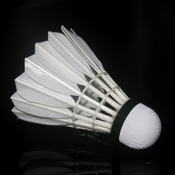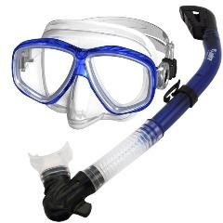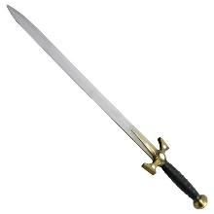
1. 2. 3. 4.
- Match the words with their definitions /5 points/
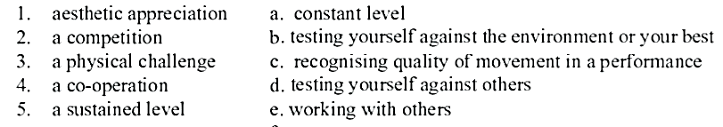
- Classify the activities in these categories. /4 points/
watching TV, travelling, eating out at a restaurant, horse riding, shopping, seeing a movie,
going to museums, camping
Physical leisure activities:
Recreational leisure activities:
- Fill in the sentences with fewer or less /5 points/
- Paul has ____________cards than Joel.
- Dad has __________ time to play than me.
- This recipe takes __________ flour than the other.
- I will have __________ eggs for breakfast than you.
- You should have __________ difficulty with this homework.
- Rewrite the sentences in the perfect passives (present, future or past) /4 points/
- We haven't checked your car yet.
- Someone has cut this tree with this saw.
- They will have caught the thieves
- He had cleaned the room
- Complete the sentences with be allowed to or be supposed to /3 points/
- She was  to cook dinner for her sick mother. It was her daily duty.
- Her children are to eat a cake after dinner. They can't do it earlier.
- I'm to help my little sister with her homework because I promised my mother.
Total point=25 Good luck!

11th grade exam for 7th unit; “Sports and entertainment” B version

- Label the sport equipment /4 points/
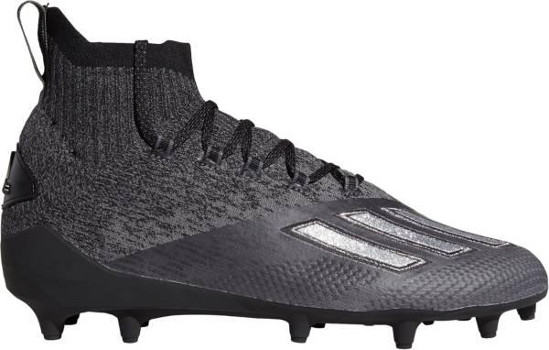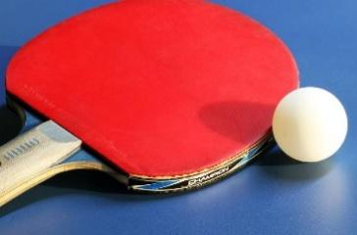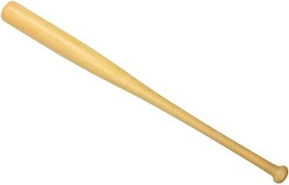
1. 2. 3. 4.
- Match the words with their definitions /5 points/
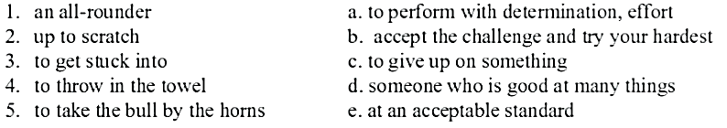
- Classify the activities in these categories. /4 points/
doing jigsaw puzzles, barbecuing, playing computer games, going to museums, drawing pictures, doing handicrafts, writing stories, reading books,
- Mental leisure activities:
- Recreational leisure activities:
- Fill in the sentences with fewer or less /5 points/
- This page has __________ math problems to complete.
- ___________ people came to the fair this year.
- The crowd was __________ animated than last year.
- Jody lost __________ teeth than you.
- The admission costs __________ money than last time.
- Rewrite the sentences in the perfect passives (present, future or past) /4 points/
- Too many people have used the same methods.
- They had invited the Browns.
- Children have eaten all the biscuits.
- He will have played a lot of computer games.
- Complete the sentences with be allowed to or be supposed to /3 points/
- My son is to be at home every day at six o'clock except on Saturdays.
- You will be to drive a car when you are eighteen.
- People are to swim in this lake.
Total point=25 Good luck!

KEY to unit-7
A version
I. Label the sport equipment /4 points/
1. Shuttle cock 2. snorkel mask 3. sword 4. hockey stick and puck
- Match the words with their definitions /5 points/
1c, 2d, 3b, 4e, 5a
- Classify the activities in these categories. /4 points/
Physical leisure activities: travelling, horse riding, shopping, camping
Recreational leisure activities: watching TV, eating out at a restaurant, seeing a movie, going to museums,
- Fill in the sentences with fewer or less /5 points/
1. fewer 2. less 3. less 4. fewer 5. less
- Rewrite the sentences in the perfect passives (present, future or past) /4 points/
- Your car hasn't been checked by us yet.
- This tree has been cut this with saw by someone.
- The thieves will have been caught by them
- The room had been cleaned by him.
- Complete the sentences with be allowed to or be supposed to /3 points/
- supposed to 2. allowed to 3. supposed to
B version
- Label the sport equipment /4 points/
1. tennis racket 2. cleats 3. ping pong paddle 4. baseball bat
- Match the words with their definitions /5 points/
1d, 2e, 3a, 4c, 5b
- Classify the activities in these categories. /4 points/
- Mental leisure activities: doing jigsaw puzzles, playing computer games, writing stories, reading books,
- Recreational leisure activities: barbecuing, going to museums, drawing pictures, doing handicrafts,
- Fill in the sentences with fewer or less /5 points/
- fewer 2. fewer 3. less 4. fewer 5. less
- Rewrite the sentences in the perfect passives (present, future or past) /4 points/
- The same methods have been used by too many people.
- The Browns had been invited by them.
- All the biscuits have been eaten by the children.
- A lot of computer games will have been played by him.
- Complete the sentences with be allowed to or be supposed to /3 points/
1. supposed to 2. allowed to 3. allowed to

11th grade exam for 8th unit; “Possessions and personal space”
A version
I. Finish the noun phrases /5 points/
- _ _ _ CHAIR
- _ _ _ _ DRYER
- _ _ _ _DRIVE
- FREE_ _ _
- CAMERA_ _ _
II. Look at the words in bold and guess the words /5 points/
camcorder, water to drink, happiness, cell phone, sleeping bag
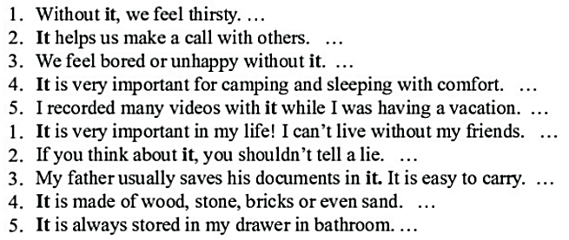
III. Add 2 words for each line /6 points/
- Abstract noun;
- Compound noun;
- Complex noun;
IV. Look at the pictures and complete the phrases. /4 points/
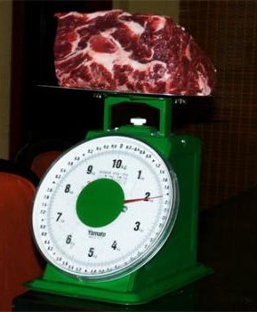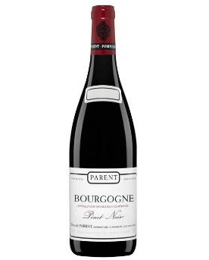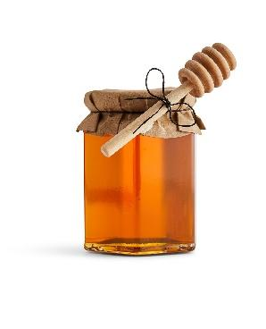
1). 2 ……. of meat 2). a …… of milk 3) a …….. of wine 4). a …… of honey
V. Put the correct preposition after each adjective. /5 points/
about from for of in
- England is famous ________ its rainy weather.
- I'm very proud ________ my daughter, she worked very hard.
- He isn't really interested ________ getting married.
- She's very excited ________ the party.
- Julie is very different ________ her sister.

TOTAL- 25 POINTS GOOD LUCK☺☺☺

11th grade exam for 8th unit; “Possessions and personal space”
B version
- Finish the noun phrases /5 points/
- _ _ _ CORDER
- WATER TO _ _ _ _ _
- SLEEPING _ _ _
- _ _ _ _ PHONE
- HAPPI_ _ _ _
- Look at the words in bold and guess the words /5 points/
friendship, honesty, hard-drive, house, hairdryer
- Add 2 words for each line /6 points/
- Complex noun;
- Compound noun;
- Abstract noun;
- Look at the pictures and complete the phrases. /4 points/
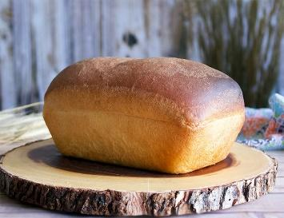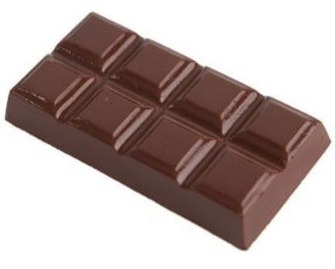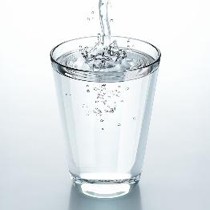
1). ……. of bread 2). a …of chocolate 3) a …….. of water 4). a …… of coffee
- Put the correct preposition after each adjective. /5 points/
from to at of to
- My niece is afraid ________ dogs.
- A ball gown is similar ________ an evening dress.
- Lucy is extremely good ________ languages.
- English cheese is very different ________ French cheese.
- Who is James married ________?

TOTAL- 25 POINTS GOOD LUCK☺☺☺

KEY TO UNIT 8
A VERSION
I. Finish the noun phrases /5 points/
- Armchair 2. Hairdryer 3.harddrive 4. Freedom 5. Cameraman
II. Look at the words in bold and guess the words /5 points/
water to drink, cell phone, happiness, sleeping bag, camcorder
III. Add 2 words for each line /6 points/
Сурагчид өөрсдийнхөөрөө хариулна. Жишээлбэл:
- Abstract noun; health, love, friendship
- Compound noun; hand saw, vacuum cleaner, dish washer
- Complex noun; my favorite song, your black jacket, long sleeved coat
IV. Look at the pictures and complete the phrases. /4 points/
1). 2 kilos of meat 2). a carton of milk 3) a bottle of wine 4). a jar of honey
V. Put the correct preposition after each adjective. /5 points/
1. for 2. of 3. about 4. in 5. from

B VERSION

- Finish the noun phrases /5 points/
- Camcorder 2.water to drink 3. Sleeping bag 4. Cell phone 5. Happiness
- Look at the words in bold and guess the words /5 points/
friendship, honesty, hard-drive, house, hairdryer
III. Add 2 words for each line /6 points/
Сурагчид өөрсдийнхөөрөө хариулна. Жишээлбэл:
- Complex noun; my favorite song, your black jacket, long sleeved coat
- Compound noun; hand saw, vacuum cleaner, dish washer
- Abstract noun; health, love, friendship
IV. Look at the pictures and complete the phrases. /4 points/
1). a loaf of bread 2). a bar of chocolate 3) a glass of water 4). a cup of coffee
V. Put the correct preposition after each adjective. /5 points/
1. of 2. to 3. at 4. from 5. to

11th grade exam for 9th unit; “Great expeditions”
A version
I. Match the words to their meanings /4 points/
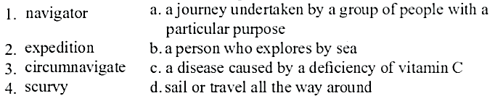
II. Sort the vocabulary into the appropriate columns /4 points/
dynasty expedition an astronaut merchant navy nobles trade route travelers
PEOPLE NOUNS
    - ……………………………… ……………………………….
    - ……………………………… ……………………………….
    - ……………………………… ……………………………….
    - ……………………………… ……………………………….
III. Fill in the missing words /3 points/
merchant, passage, coral, apprentice, mosquitoes, navy
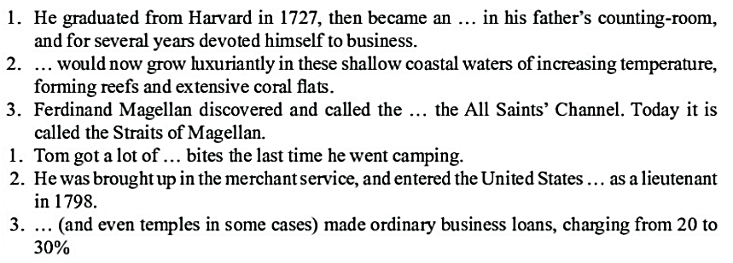
IV. Turn statements into Reported speech. /5 points/
- John said, “I saw that movie on Wednesday.”
………………………………………………………………………………………..
- George said, “I finished studying my lesson.”
………………………………………………………………………………………..
- Mr. Smith said, “I will refuse their offer.”
……………………………………………………………………………………….
- Mary says, “John speaks English well.”
……………………………………………………………………………………….
- Mrs.Jones: “The bride and the groom are very nice young people.”
………………………………………………………………………………………

TOTAL- 16 POINTS GOOD LUCK☺☺☺
11th grade exam for 9th unit; “Great expeditions”
B version
- Match the words to their explanations /4 points/
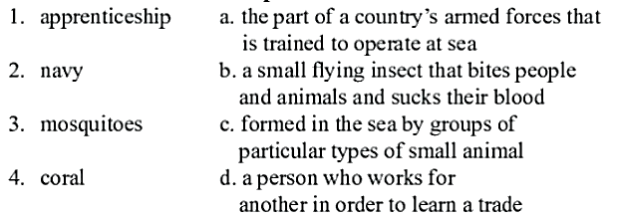
- Sort the vocabulary into the appropriate columns /4 points/
extreme, to overcome hardship, tremendous, wonderful, to gain profit, to apprentice, popular, to commemorate
ADJECTIVES VERBS
    - ……………………………… ……………………………….
    - ……………………………… ……………………………….
    - ……………………………… ……………………………….
    - ……………………………… ……………………………….
- Fill in the missing words /3 points/
merchant, passage, coral, apprentice, mosquitoes, navy
- Turn statements into Reported speech. /5 points/
  - Mr. Roberts: “The bride is wearing a beautiful wedding dress.”
………………………………………………………………………
  - She said “We didn’t see everything”
……………………………………………………………………….
  - Mr. Brown said, “I don’t drive a car in the rush hour.”
………………………………………………………………………
  - Mrs.Jones: “The bride and the groom are very nice young people.”
…………………………………………………………………………
  - He always says “I’m rich”
……………………………………………………………………………………….
TOTAL- 16 POINTS GOOD LUCK☺☺☺

KEY TO UNIT 9
A VERSION
I. Match the words to their meanings /4 points/
1b, 2a, 3d, 4c
II. Sort the vocabulary into the appropriate columns /4 points/
PEOPLE NOUNS
    - an astronaut dynasty
    - merchant expedition
    - navy nobles
    - travelers trade route
- Fill in the missing words /3 points/
1. apprentice, 2. coral, 3. passage
- Turn statements into Reported speech. /5 points/
- John said that he had seen that movie on Wednesday.
- George said that he had finished studying his lesson.
- Mr. Smith said that he would refuse their offer.
- Mary says that John speaks English well.
- Mrs.Jones said that the bride and the groom were very nice young people.

B version

- Match the words to their explanations /4 points/
1d, 2a, 3b, 4c
- Sort the vocabulary into the appropriate columns /4 points/
ADJECTIVES VERBS
    - extreme, to overcome hardship,
    - tremendous, to gain profit,
    - wonderful, to apprentice,
    - popular, to commemorate
- Fill in the missing words /3 points/
1. mosquitoes 2. navy 3. merchant
- Turn statements into Reported speech. /5 points/
  - Mr. Roberts said that the bride was wearing a beautiful wedding dress.
  - She said that they hadn’t seen everything.
  - Mr. Brown said that he didn’t drive a car in the rush hour.
  - Mrs. Jones said that the bride and the groom were very nice young people.”
  - He always says that he is rich

11th grade exam for 10th unit; “Wonders of Mongolia”
A version
I. Label the pictures /5 points/
1. mountain forest steppe 2. Gobi desert zone 3. steppe zone 4. desert steppe zone 5. wetland zone
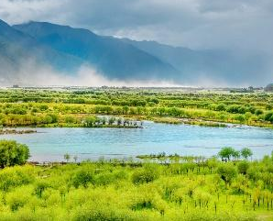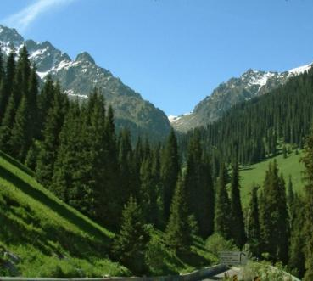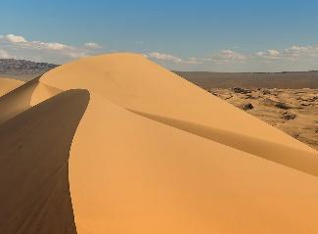
a b c d e
II. Translate the given words /5 points/
- insect repellent
- hiking boots
- compass
- camcorder
- first-aid-kit
III. Match the new words to their meaning /5 points/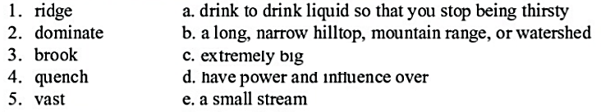
IV. Change the sentences into passive form /5 points/
- Those prisoners had robbed five banks.
- Had Dr. Richard saved Silvia's life?
- The Americans hadn’t discovered another planet.
- George has designed the plan of that villa
- Firefighters have put out the fire successfully.
- Complete the sentences using as…as and so... as /5 points/
Mozart / Beethoven (famous)- Mozart is as famous as Beethoven.
A church / a cathedral (not big)- A church is not so big as a cathedral.
- January / February (cold)
- Spain / Portugal (hot)
- A cat / a dog (not friendly)
- Italian food / French food (delicious)
- A bike / a motorbike (not fast) Total point=25 Good luck!

11th grade exam for 10th unit; “Wonders of Mongolia”
B version
- Label the pictures /5 points/
1. Bogd khan palace museum 2. Central museum of Mongolian dinosaurs 3. National history museum 4. Kharhorin museum 5. Erdene zuu monastery
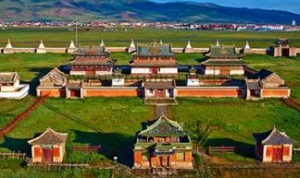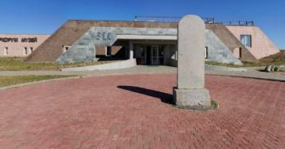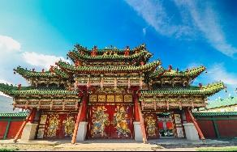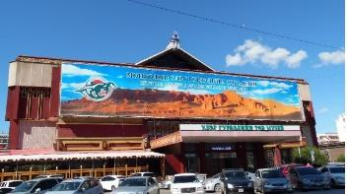
a b c d e
- Translate the given words /5 points/
- a passport
- binoculars
- map
- toiletries
- torch
- Match the new words to their meaning /5 points/
- excavation  - exploration  - aristocrat  - tomb  - artifacts | - the activity of searching and finding out about something  - to remove earth that is covering old objects buried in the ground in order to discover things about the past  - a large stone structure or underground room where someone, \especially an important person, is buried  - a person of high social rank  - an object made by a human being, typically one of cultural or historical interest
- Change the sentences into passive form /5 points/
- Policemen have arrested the bank robbers.
- We had planned our party already
- Those people had broken all windows.
- Had Zaya sung an opera?
- Ganaa hasn’t finished his project
- Complete the sentences using as…as and so... as /5 points/
Mozart / Beethoven (famous)- Mozart is as famous as Beethoven.
A church / a cathedral (not big)- A church is not so big as a cathedral.
- Australia / Germany. (not small)
- Life in a town / life in a village. (busy)
- Wine / champagne. (strong)
- Chinese / English. (not easy)
- Hamburg / Dusseldorf. (large)
Total point=25 Good luck!
KEY to unit-10 A version
I. Label the pictures /5 points/
  - wetland zone b. desert steppe zone c. mountain forest steppe d. Gobi desert zone e. steppe zone
II. Translate the given words /5 points/
- шавьж үргээгч, шавьжны хор 2. ууланд авиралтын гутал 3. луужин 4. видео камер 5. Анхны тусламжийн хайрцаг
III. Match the new words to their meaning /5 points/
1b 2d 3e 4a 5c
IV. Change the sentences into passive form /5 points/
- Five banks had been robbed by those prisoners.
- Had Silvia's life saved by Dr. Richard?
- Another planet hadn’t been discovered by the Americans.
- The plan of that villa has been designed by George.
- The fire have been put out by firefighters successfully.
V. Complete the sentences using as…as and so... as /5 points/
- January is as cold as February. 2. Spain is as hot as Portugal
3. A cat is not so friendly as a dog 4. Italian food is as delicious as French food.
5. A bike is not so fast as a motorbike

B version
    - Label the pictures /5 points/
1. Bogd khan palace museum-c 2. Central museum of Mongolian dinosaurs-d 3. National history museum-e 4. Kharhorin museum-b 5. Erdene zuu monastery-a
    - Translate the given words /5 points/
- Үнэмлэх 2. хоёр нүдний дуран 3. газрын зураг 4. ариун цэврийн хэрэгсэл 5. Гар чийдэн
    - Match the new words to their meaning /5 points/
1b, 2a, 3d, 4c, 5e
    - Change the sentences into passive form /5 points/
- The bank robbers have been arrested by policemen.
- Our party had already been planned /by us/.
- All windows had been broken by those people.
- Had an opera been sung by Zaya?
- His project hasn’t been finished by Ganaa
    - Complete the sentences using as…as and so... as /5 points/
- Australia is not so small as Germany. 2. Life in a town as busy as life in a village.
3. Wine is as strong as champagne. 4. Chinese is not so easy as English.
5. Hamburg is as large as Dusseldorf.

Unit-6; “Habitat interaction”
- Caterpillar-
- Cell-
- Cellular-
- Chemical reaction-
- Absorb-
- Omnivore-
- Oxygen-
- Predator-
- Prey-
- Adapt-
- Affect-
- Algae-
- Alter-
- Amino acid-
- Arctic hare-
- Arid-
- Balance-
- Behaviour-
- Biodiversity-
- Breathe-
- Burrow-
- Camouflage-
- Candidate-
- Carnivore-
- Hibernation-
- Hierarchy-
- Insect-
- Conifer-
- Conserve-
- Natural factor-
- Offspring-
- Rainforest-
- Recycle-
- Release-
- Consumer-
- Coyote-
- Crab-
- Crow-
- Deceased animal-
- Decline-

Unit-6; “Habitat interaction”
- Intensity-
- Habitat-
- Harsh environment-
- Hawk-
- Starch-
- Interact-
- Magpie-
- Decompose-
- Disappear-
- Endangered-
- Enemies-
- Experiment-
- Falcon-
- Repairman-
- Respiration-
- Scavenger-
- Seagull-
- Fertile soil-
- Food chain-
- Fungi-
- Fur-
- Grasshopper-
- Survive-
- Unbalance-
- Unique-
- Vibrate-
- Vote-
- Vulture-
- Woodland-
- Herbivore-
- Hibernate-
- Insectivore-
- Mammal-
- Marmot-
- Medicinal properties-
- Migration-
- Seal-
- Single-celled organism-
- Sniff-
- Soil-

